ASSIGNMENT -7

Summarizing Data with Aggregate Functions.
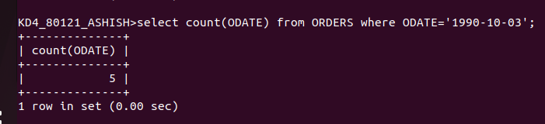
1) Write a query that counts all orders for October 3.

2) Write a query that counts the number of fifferent non-NULL city values in the customers table.
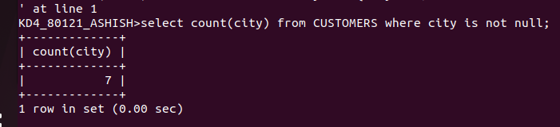
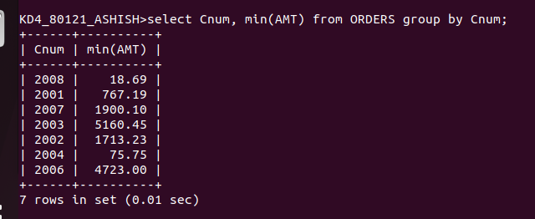
3)Write a query that selects each customer’s smallest order.

4)Write a query that selects the first customers in alphabetical order, whose name begins with G.

5)Write a query that selects the highest rating in each city
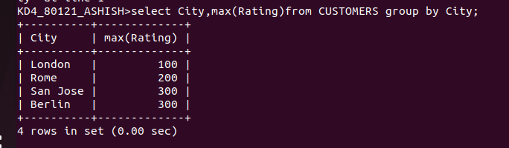
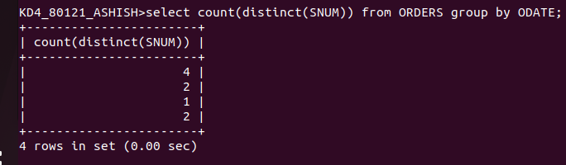
6) Write a query that counts the number of salespeople registering orders for ech day, ( If a salespeople has more than one order on a givenday, he or she should be counted only once)

